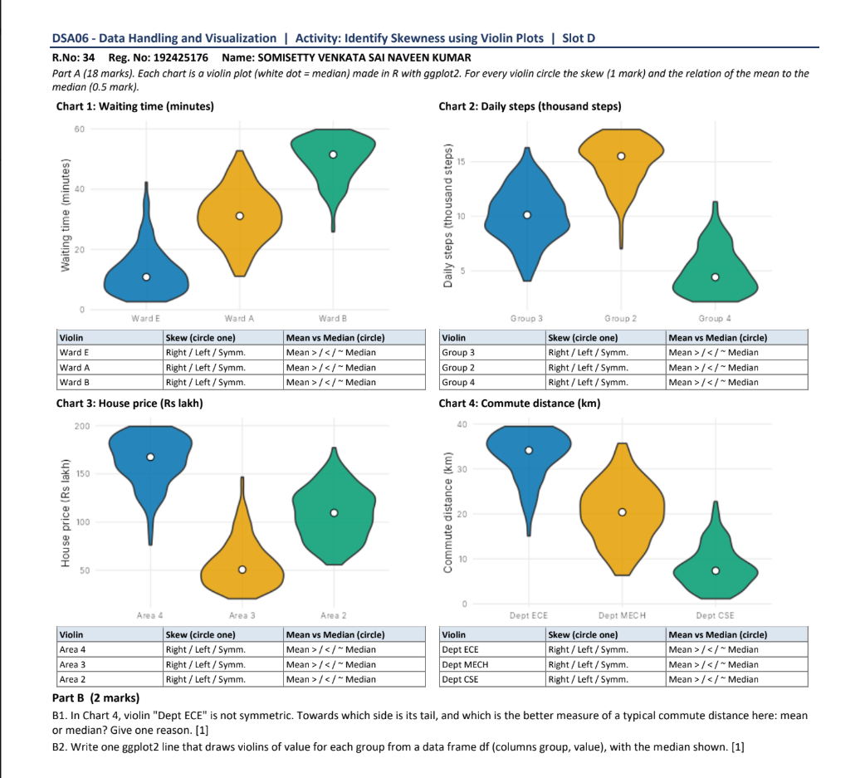
Answers
Part A
Chart 1: Waiting time (minutes)
Violin | Skew | Mean vs Median
Ward E | Right skew | Mean > Median
Ward A | Symmetric | Mean ~ Median
Ward B | Left skew | Mean < Median
Chart 2: Daily steps (thousand steps)
Violin | Skew | Mean vs Median
Group 3 | Symmetric | Mean ~ Median
Group 2 | Left skew | Mean < Median
Group 4 | Right skew | Mean > Median
Chart 3: House price (Rs lakh)
Violin | Skew | Mean vs Median
Area 4 | Left skew | Mean < Median
Area 3 | Right skew | Mean > Median
Area 2 | Symmetric | Mean ~ Median
Chart 4: Commute distance (km)
Violin | Skew | Mean vs Median
Dept ECE | Left skew | Mean < Median
Dept MECH | Symmetric | Mean ~ Median
Dept CSE | Right skew | Mean > Median
Part B
B1. The tail of the violin "Dept ECE" points towards the lower side (left), i.e. towards shorter commute distances, so it is left-skewed. The median is the better measure of a typical commute distance here, because the mean is pulled down by the long lower tail while the median is not affected by these extreme values.
B2. One ggplot2 line:
ggplot(df, aes(x = group, y = value)) + geom_violin() + stat_summary(fun = median, geom = "point", colour = "white")

